A preposition is a word that shows relationships of location or direction. A prepositional phrase is a group of words that show location and direction. Hint: prepositions are usually found inside groups of words (phrases).
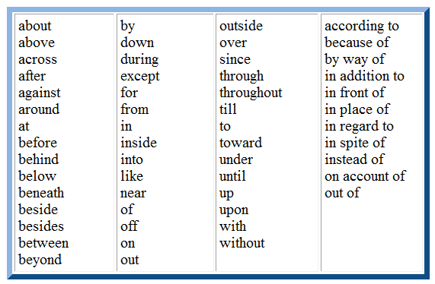
**But is very seldom a preposition. When it is used as a preposition but means the same as except-Everyone played tag with us but Johnny. But normally functions as a coordinating conjunction.

A preposition is a word that shows relationships of location or direction. A prepositional phrase is a group of words that show location and direction. Hint: prepositions are usually found inside groups of words (phrases).
**But is very seldom a preposition. When it is used as a preposition but means the same as except-Everyone played tag with us but Johnny. But normally functions as a coordinating conjunction.

