Create Your Own “Monster” Activity

You will create a model of Frankenstein’s “monster”. You should attempt to make your creation fit as closely to the book’s description as possible (not full size!) OR explain a valid reason/purpose for changing it. Again, BOOK’S description. Don’t try to base it on a movie version, most of them are inaccurate!

There is no need, obviously, to gather materials in the same way Victor Frankenstein did—you would get arrested and I would no longer have a job! So…be creative!! Use Lego’s or plastic or milk jugs or fabric or old materials or paper towel rolls or anything else you can find…
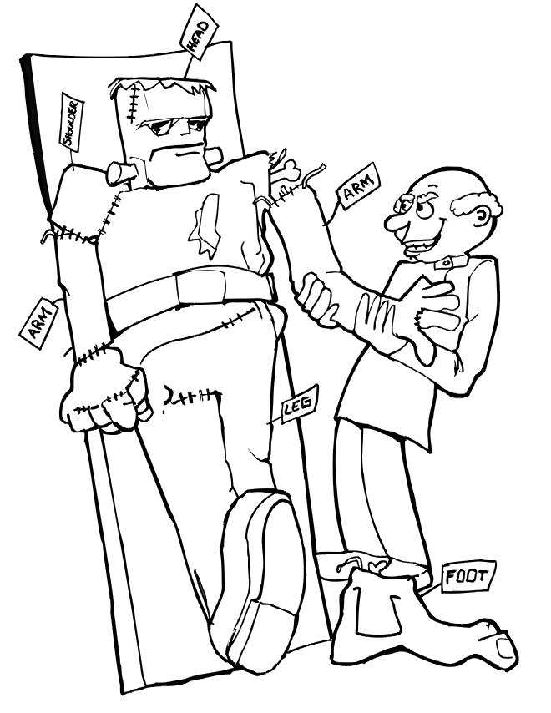
BE CREATIVE!!

While creating your “monster,” keep a journal as Frankenstein did. Document each day you work on him and what task is completed that day. You must also document your feelings and expectations for the thing you create. Remember, it’s going to be ‘alive’ so how do you feel “playing God” and “creating” life? (We are pretending here—just go with it!).

Finally, create a way for your creature to “come to life” through talking, moving, creating a video, etc…again…GET CREATIVE!

Groups should be prepared to present on:

You will turn this in one copy of this sheet for credit with your presentation!

Group Member Names:

Rubric:
Requirement Points Possible Points Earned
Lifelike Qualities (talking, moving, etc.): 5 pts.
Features Match Description from Frankenstein: 5 pts.
Journal is detailed with procedures: 10 pts.
Journal includes EMOTION as described above: 10 pts.
Overall Effort and Quality of Creating and Presenting: 10 pts.
Works hard during class time, presents professionally, etc.
Individual Score for Contribution to Group: 10 pts.

